**Assignment –5**

**Relational and Logical Operators.**

1. **Write a query that will give you all orders for more than Rs. 1,000.**

mysql> select* from Orders

-> where Amt>1000;

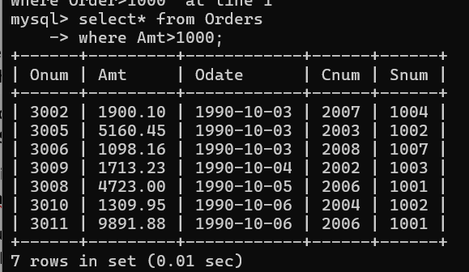

1. **Write a query that will give you the names and cities of all salespeople in London with a commission above .10.**

mysql> select Sname, City

-> from SALESPEOPLE

-> where City = 'London' and Comm>0.10;

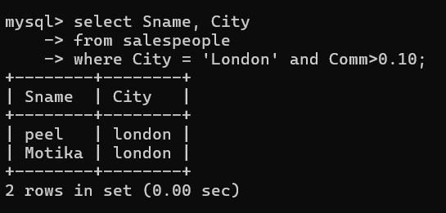

1. **Write a query on the Customers table whose output will exclude all customers with a rating <= 100, unless they are located in Rome.**

mysql> select*from customers

-> where rating>100 or city = 'Rome';

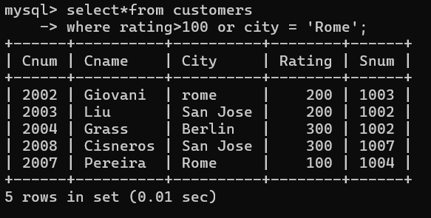

1. **What will be the output from the following query? Select * from Orders where (amt < 1000 OR NOT (odate = ‘1990-10-03’ AND cnum > 2003));**

mysql> select*from orders

-> where (amt <1000 or not (odate = '1990-10-03' and cnum>2003));

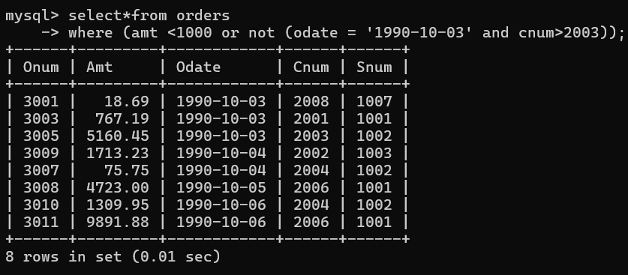

1. **What will be the output of the following query? Select * from Orders where NOT ((odate = ‘1990-10-03’ OR snum >1006) AND amt >= 1500);**

mysql> select *from Orders

-> where not((odate = '1990-10-03' or snum>1000)and amt>= 1500);

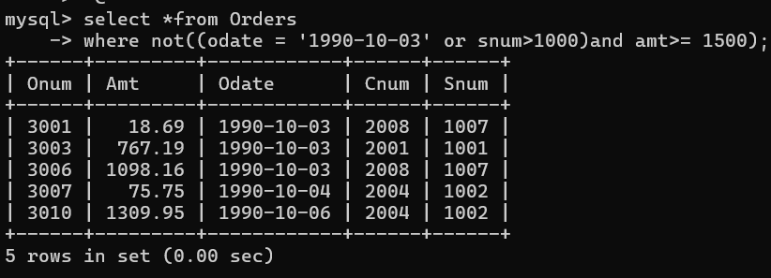

**6) What is a simpler way to write this query? Select snum, sname, city, comm From Salespeople where (comm > .12 OR comm<0.14);**

mysql> select snum, sname, city,comm

-> from salespeople

-> where comm between 0.12 and 0.14;

